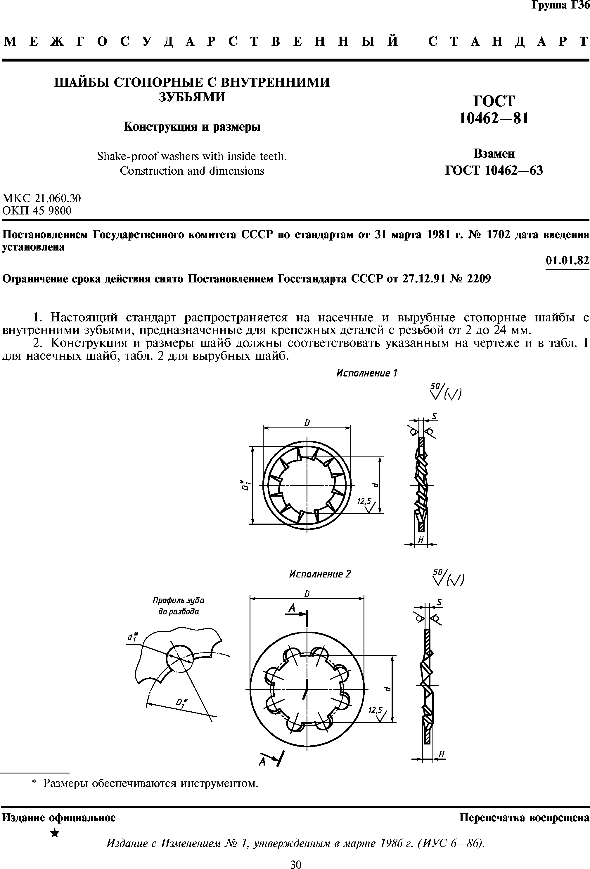

[каркасный](http://geobases.ru/house/sale/%D0%BF%D1%80%D0%BE%D0%B4%D0%B0%D0%B6%D0%B0_%D0%B4%D0%BE%D0%BC%D0%BE%D0%B2_0) [дом](http://geobases.ru/house/sale/%D0%BF%D1%80%D0%BE%D0%B4%D0%B0%D0%B6%D0%B0_%D0%B4%D0%BE%D0%BC%D0%BE%D0%B2_0)

