DIN 741. 3a+l4M ,EtflR CTaflbHblX KaHaTOB

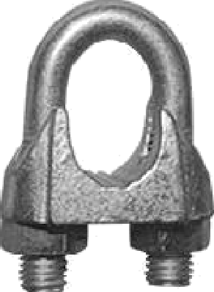
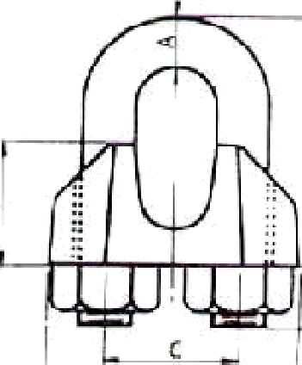
DIN741 WIRE ROPE CLIPS

H

SIZE | A | B | C | D | F | H |  | KRS/10OPCS | UNNY | CARTON
3 | 4 | 20 | 9 | 12 | 21 | 10 | 10 | 1.4 | 20 00 | 10 0 •18=1800
5 | 5 | 24 | 11 | 13 | 23 | 11 | 10 | 1.5 | 10 00 | 100 •18=180O
6.5 | 5 | 28 | 13 | JS | 26 | 12 | 11 | 2.1 | 10 00 | 10 0 •12=1200
8 | 6 | 34 | 16 | 19 | 30 | 14 | 15 | 4.1 | 800 | 100•8=800
10 | 8 | 42 | 19 | 22 | 34 | 18 | 17 | 6.8 | 300 | 20• 18=S600
11 | 8 | 44 | 20 | 22 | 36 | 19 | 18 | 7.2 | 250 | 20• 18=3600
13 | 10 | 55 | 24 | S0 | 42 | 23 | 21 | 13 | 200 | 20 • 8 =160
14 | 10 | 57 | 25 | SO | 44 | 23 | 22 | 13.5 | 200 | 20•8=160
16 | 12 | 63 | 29 | 33 | 50 | 26 | 26 | 21 | 100 | 10=8=80
19 | 12 | 75 | 32 | 38 | 54 | 29 | 30 | 28 | 100 | 10•6=60
22 | 14 | 85 | 37 | 44 | 61 | 33 | 34 | 40 | 50 | 10=6=60
26 | 14 | 95 | 41 | 45 | 65 | 35 | 37 |  | 50 | 10=6=60
SO | 16 | 110 | 48 | 50 | 74 | 37 | 43 | 6 6 | 50 | LOSE
34 | 16 | 120 | 52 | 55 | 80 | 42 | 50 | 8 5 | 45 | LOSE
40 | 16 | 140 | 58 | 60 | 88 | 45 | 55 | 104 | 25 | LOSE

